TOS 4.2 tnas.link Certificate expired Solution
Applicable system version: TOS 4

Step 1 ：Download the compressed certificate package and decompress it using the decompression tool.
Download link: https://download3.terra-master.com/Utilities/tnas.onlie/Certificate.rar
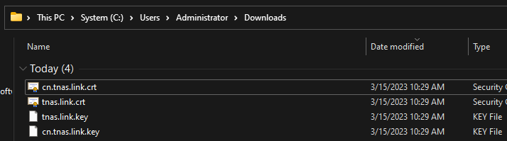
Step 2: Upload the global server certificate
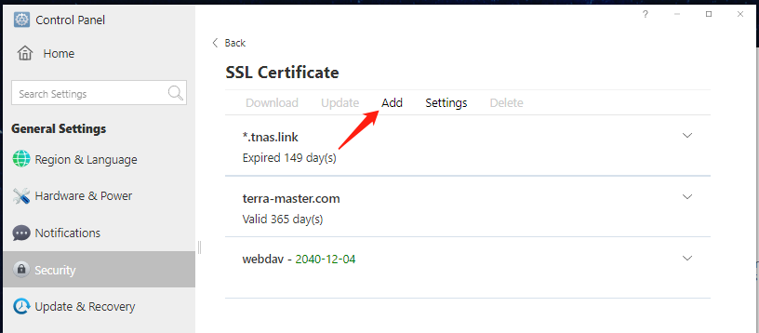
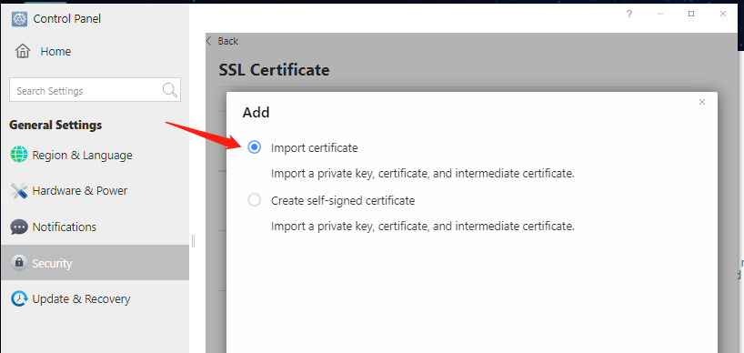
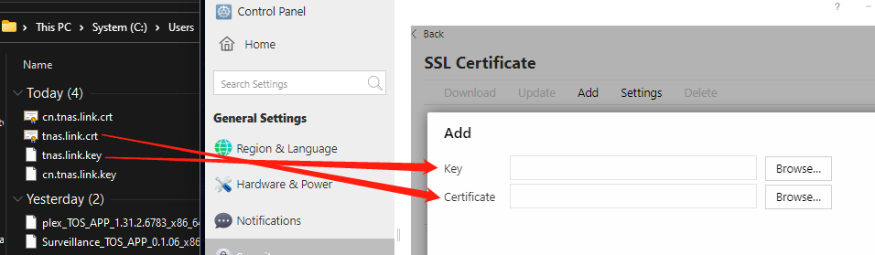
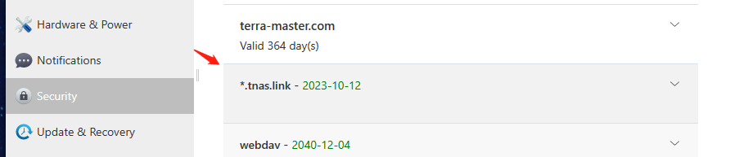

Step 3: Log in to ssh and run the following commands：
mv /etc/ssls/\*.tnas.link.crt /etc/nginx/ssl/tnas.link.crt
mv /etc/ssls/\*.tnas.link.key /etc/nginx/ssl/tnas.link.key
How to use SSH login terminal: https://forum.terra-master.com/en/viewtopic.php?f=78&t=2350

Step 4: Upload the Chinese server certificate.
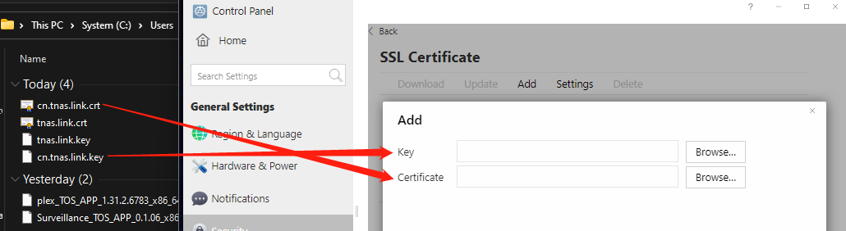
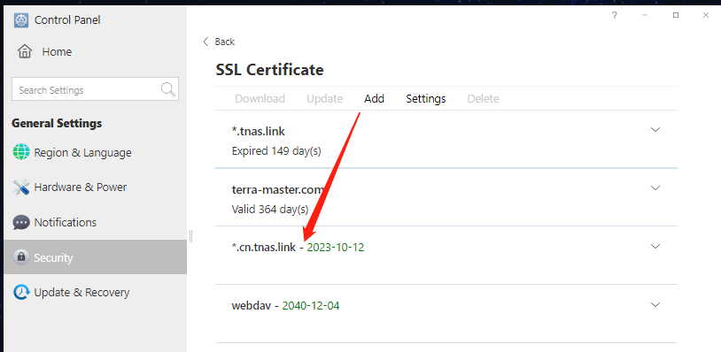
Step 5: Log in to ssh and run the following commands：
mv /etc/ssls/\*.cn.tnas.link.key /etc/nginx/ssl/cn.tnas.link.key
mv /etc/ssls/\*.cn.tnas.link.crt /etc/nginx/ssl/cn.tnas.link.crt
How to use SSH login terminal: https://forum.terra-master.com/en/viewtopic.php?f=78&t=2350
Step 6: Change the permission of the uploaded certificate
chmod 755 /etc/nginx/ssl/*
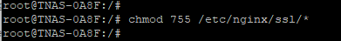
Step 7: Select Global Server and re-enable TNAS.online
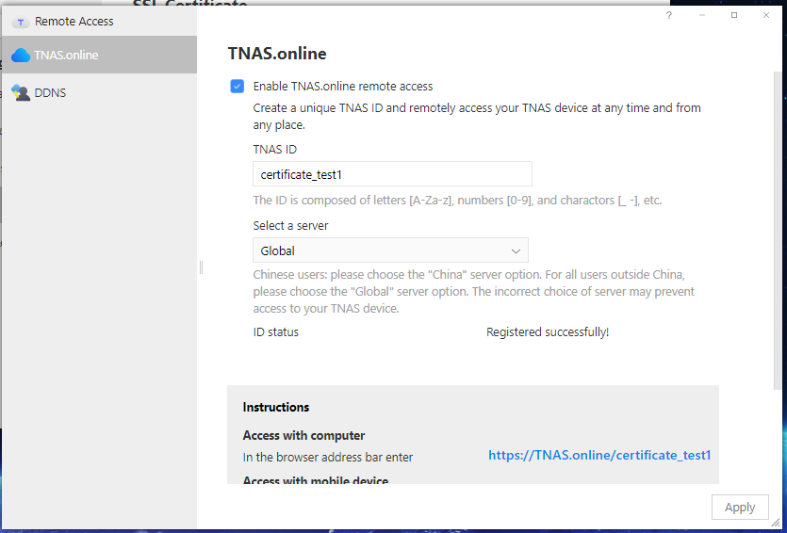
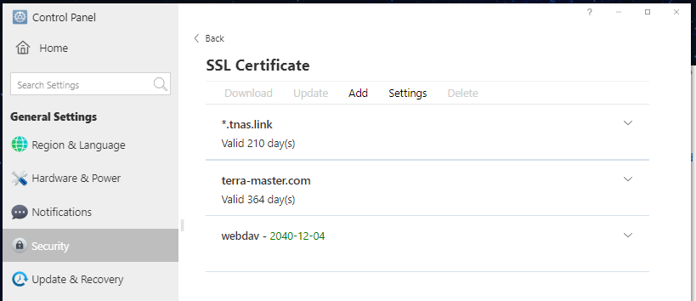
Step 8: Select the Chinese server and re-enable TNAS.online
